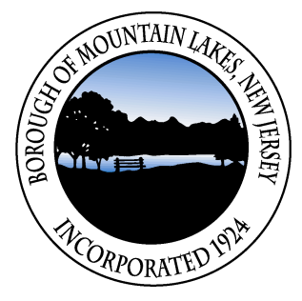
AGENDA FOR THE COUNCIL MEETING OF THE BOROUGH OF MOUNTAIN LAKES
HELD AT ML HIGH SCHOOL, 96 POWERVILLE ROAD, MOUNTAIN LAKES, NJ 07046
JANUARY 24, 2024
PUBLIC SESSION – BEGINS AT 7PM

- CALL TO ORDER AND OPEN PUBLIC MEETINGS ACT STATEMENT – Mayor
This meeting is being held in compliance with Public Law 1975, Chapter 231, Sections 4 and 13, as notice of this meeting has been reported to The Citizen and the Morris County Daily Record and The Star Ledger on January 4, 2024 and posted in the municipal building.
- ROLL CALL ATTENDANCE – Borough Manager
- FLAG SALUTE – Mayor
- BUDGET DISCUSSION
- 2024 Budget
- PUBLIC COMMENT
Please state your name for the record. Each speaker is limited to one (1) comment of no more than five (5) minutes and no yielding of time to another person.
- ADJOURNMENT

